DoV SG: Scenario-based findings

National system peak
  - All parties see the main value from DSR to be focused on the winter peak. For those parties looking at the national picture, the winter peak coincides and in the majority of cases, the National System Peak overlaps local network peak demand. However, the DNO winter peak can be slightly staggered for two main reasons:

• The issue for distribution equipment is based on the build-up of heat caused by load and not only on momentary load

• Local characteristics may also affect the peak timing. Some substations which feed predominately domestic loads in some metropolitan areas, the peak happens later to reflect workers return from work later than the national average. Areas where the domestic peak is from storage heating overnight are also anomalies.
  - The party with potentially the highest value for reducing national system peak is deemed to be the suppliers, however all parties have an interest in seeing it reduced. Even if energy prices become more dependent on intermittent generation is it still seen that the winter peak will be the key time of year for all actors to realise value from DSR.
  - It was seen in the vast majority of use cases that most value lays at a national level and rather than local, and DSR actions to tackle the national issue will also have the bonus of reducing local network costs in most cases. The Low Carbon London trial included this finding in its outputs provided to the workstream.
  - The value from DSR to tackle national system peak is estimated at between £11 and £247 per MW per day. The low figure is based on Ofgem's EBSCR (Electricity Balancing Significant Code Review) predictions of the highest 0.5% of cash-out prices expected in 2020 if PAR (Price Average Reference) is reduced to 1,. This is an incomplete data set so £11 is a conservative estimate. The high figure is based on the value of lost load under the EBSCR of £6000/MWh and that it may become the marginal price up to 15 periods a year (aligning with current triad avoidance periods).

Local network peak demand
  - Sometimes, due to local factors, the DNO peak does not necessarily overlap with the national daily peak. There is value for the DNO in reducing this peak, though the value is based on the local firm capacity limit and the expected demand. In many areas there would be little value in using DSR to reduce local peaks, as the network has sufficient capacity to deal with the expected peak loads.
  - Current DNO thinking is DSR for this issue is most viable at primary substation level and via industrial and commercial customers. However there may be scope in future for DNOs to achieve value from management at lower voltage levels and via domestic customers with management via electric vehicles, heat pumps with storage or possibly community energy schemes. To affect the operation of primary substations, the volume of energy needed means a significant number of domestic customers connected to the substation would have to participate in DSR to make a difference.

Post fault management
  - The driver for DNOs is maintaining security of supply under N-1 fault situations to address localised peak loading for situations when a fault occurs and the load is forecast to peak above the firm capacity of the substation before full network capacity can be restored. Though this localised peak will, in most cases, overlap the time period of the national system peak, the DNOs cost driver under this scenario will be stronger than that of suppliers.
  - The driver for DNOs is maintaining security of supply under N-1 fault situations to address localised peak loading for situations when a fault occurs and the load is forecast to peak above the firm capacity of the substation before full network capacity can be restored, as shown on the diagram below. Though this localised peak will, in most cases, overlap the time period of the national system peak, the DNOs cost driver under this scenario will be stronger than that of suppliers.

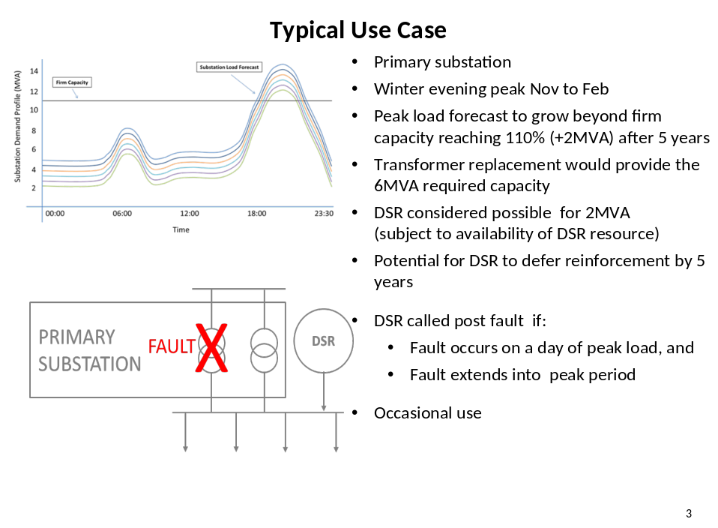
  - Post fault management is expected to be an infrequent use of DSR, but high value.

DSR impact on supporting post fault management
  - Distribution networks will benefit from action to reduce demand after faults in "hot spots", or areas where there would otherwise be a need for reinforcement to meet security standards. In these areas, investment deferred could be worth between £40k and £300k/MW, depending on rural/urban location and voltage level, according to Poyry’s (2011), assessment of DSR price signals. But the actual value will be based on the counterfactual avoided or deferred reinforcement costs.

Local peak generation / low demand
  - This is seen as a growing issue for the TO, SO and DNO. Each are interested in solutions that DSR could provide in summer when local exported energy outstrips demand causing localised reverse power flows and potential thermal or voltage issues. There are opportunities seen by both parties to tackle the issue, though the DNO value is on a more localised basis and will likely be the first party to enact DSR due to a value proposition developing.
  - This could be an opportunity for community energy groups and is an area being looked at by WPD with its Sunshine Tariff trial.

DSR impact on supporting local peak generation / low demand
  - This will depend on the nature and level of connection of the generation. A surplus of domestic PV generation would require advanced voltage control, which is currently being explored in LCNF projects, but BAU costs are not yet available. In some cases, PV will self-disconnect if voltage levels are exceeded. (Note that under ED1 rules, the "disrupting" customers bear none of this cost.)
  - For a wind farm, for instance, DSR would be one of a suite of options available to the DNO and customer at the time the connection is made, including a flexible connection, and the choice would essentially be for the customer.

Wholesale market
  - The national network infrastructure has issues in the extremes of operation such as the winter peak, peak generation / low demand and summer minimum. For the DNO and TO the DSR value is prominently focused in these extremes. The wholesale market is the main value driver in other periods of the year and the value is expected to primarily sit with suppliers and secondarily with the SO.

DSR impact on the wholesale market from daily demand response
  - Value from DSR would be high per kWh if it was at a moderate level. However higher volumes of DSR would have a lessening impact on the average cost saving, as the off peak lower cost generation capacity is used up and the most expensive peak generation is the first not to be used. DSR would also change generation plant planning as more base-load plant would be needed and less generation built for frequent but short term use. It may, however, increase some peak costs for a period as under-utilised generation may try and recover lost revenue in fewer hours of use than originally expected.
  - The planning assumption is that there is a dynamic element to the DSR so it could react to wind and solar generation. There is a value estimate of 2-5p per day per customer if they swap 1 kwh of demand each on average. The differential would be higher on winter peak days. The value estimate includes carbon price impacts. The estimated value does not necessarily represent the most expensive period of the day to the cheapest, but close to this.

Capacity market
  - Due to the wholesale market and national system peak both being led by generation costs it was deemed unnecessary to complicate the work and separate capacity market, but leave it as third category of DSR that can be derived from within the national system peak scenario and the wholesale market.

PAR is the volume used to calculate the cash-out price. So a PAR of 1 means Elexon only use the most expensive 1MWh of balancing actions by NG to calculate the price

